R PROGRAMMING LAB:
Name: SK HALEEM SAGAR
Register No: 192372038
Course code: (CSA1606)
Course: DWDM

EXPERIMENT - 1: ADDITION

AIM:
To write/prove the R program for addition using RStudio.

PROGRAM:
num1 <- 10
num2 <- 20

x <- num1
y <- num2
z <- x + y

print(z)
OUTPUT:
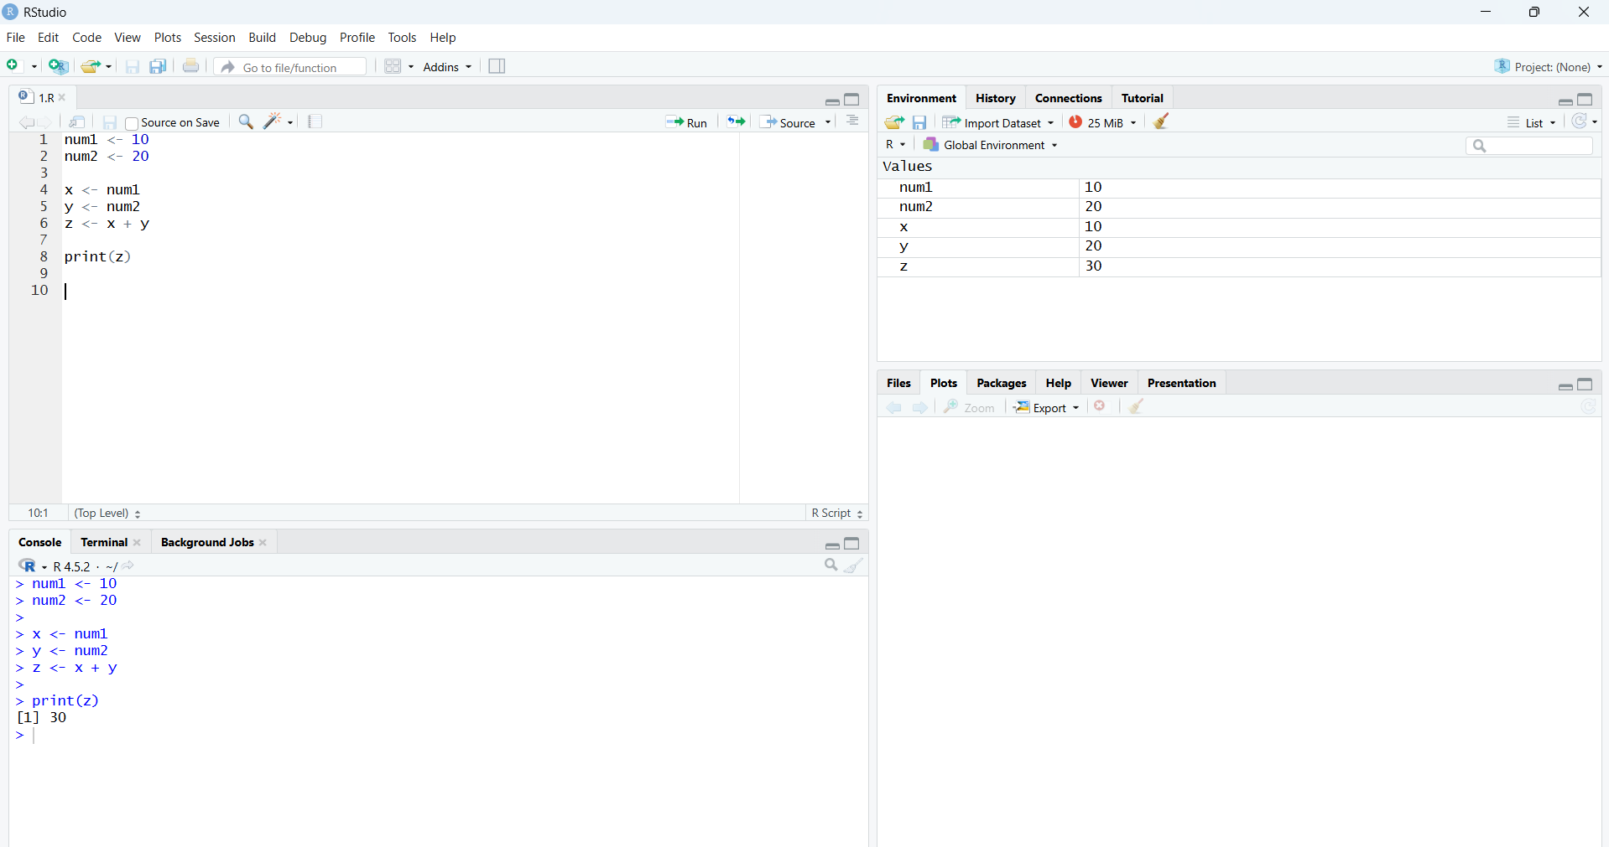

RESULT: Thus the R program for addition was executed successfully.

EXPERIMENT - 2: SUBTRACTION

AIM:
To write/prove the R program for subtraction using RStudio.
PROGRAM:
num1 <- 30
num2 <- 20
x <- num1
y <- num2
z <- x - y
print(z)
OUTPUT:
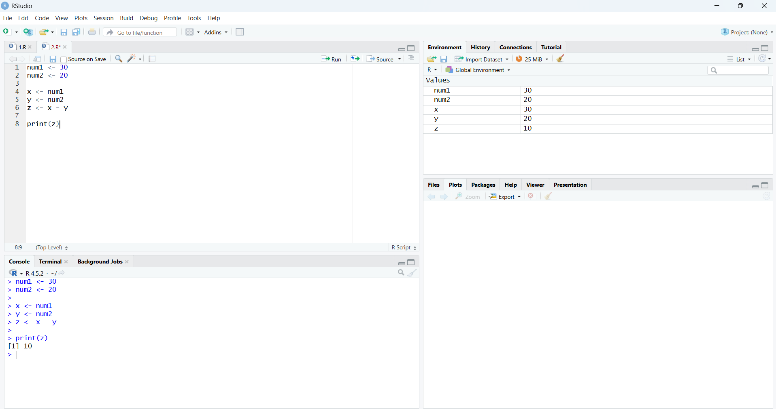

RESULT: Thus the R program for subtraction was executed successfully.

EXPERIMENT - 3: MULTIPLICATION

AIM:
To write/prove the R program for multiplication using RStudio.

PROGRAM:
x <- num1
y <- num2
z <- x * y
print(z)
OUTPUT: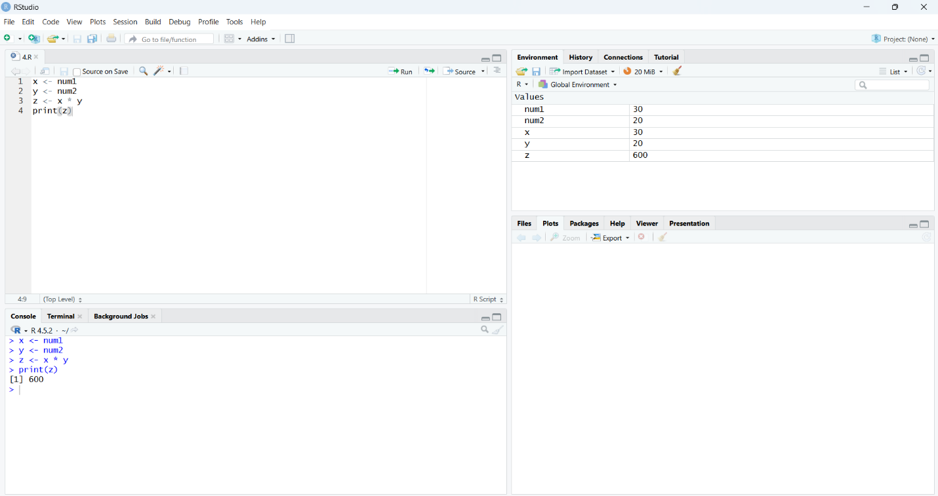

RESULT: Thus the R program for multiplication was executed successfully

EXPERIMENT - 4: DIVISION

AIM:
To write/prove the R program for division using RStudio.

PROGRAM:
x <- num1
y <- num2
z <- x / y
print(z)
OUTPUT:

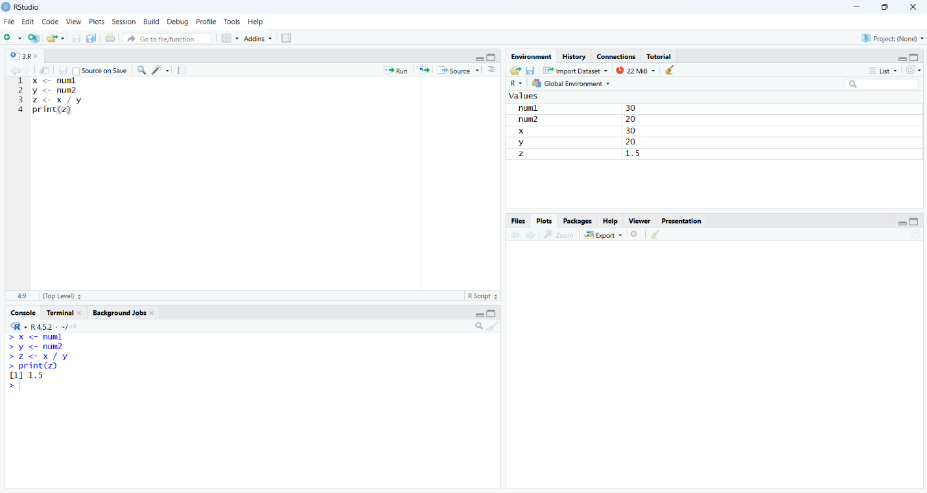
RESULT: Thus the R program for division was executed successfully.

EXPERIMENT - 5: ODD OR EVEN

AIM:
To write/prove the R program for odd or even using RStudio.

PROGRAM:
num <- 68
if ((num %% 2) == 0) {
print(paste(num, "is Even"))
} else {
print(paste(num, "is Odd"))
}
OUTPUT:
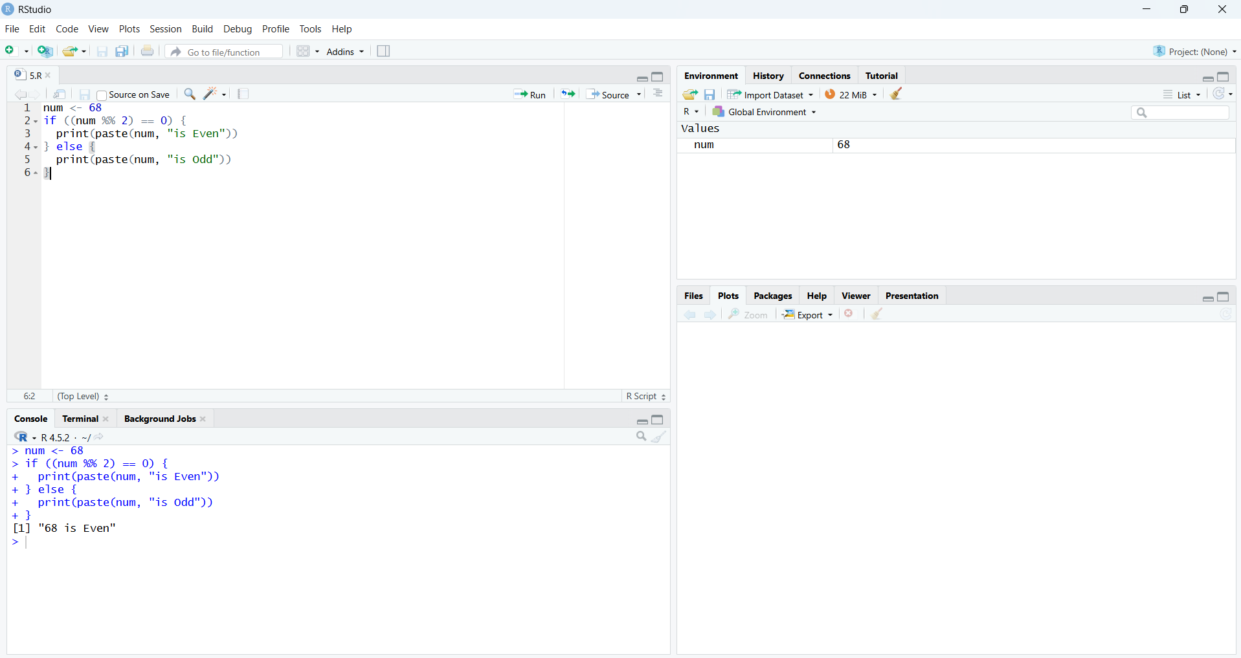

RESULT: Thus the R program to check odd or even was executed successfully.

EXPERIMENT - 6: MEAN, MEDIAN, MODE

AIM:
To write/prove the R program for mean, median, mode using RStudio.

PROGRAM:
age <- c(26,27,28,29,30,90)
mean(age)
median(age)
as.numeric(names(sort(table(age), decreasing = TRUE)[1]))
OUTPUT:
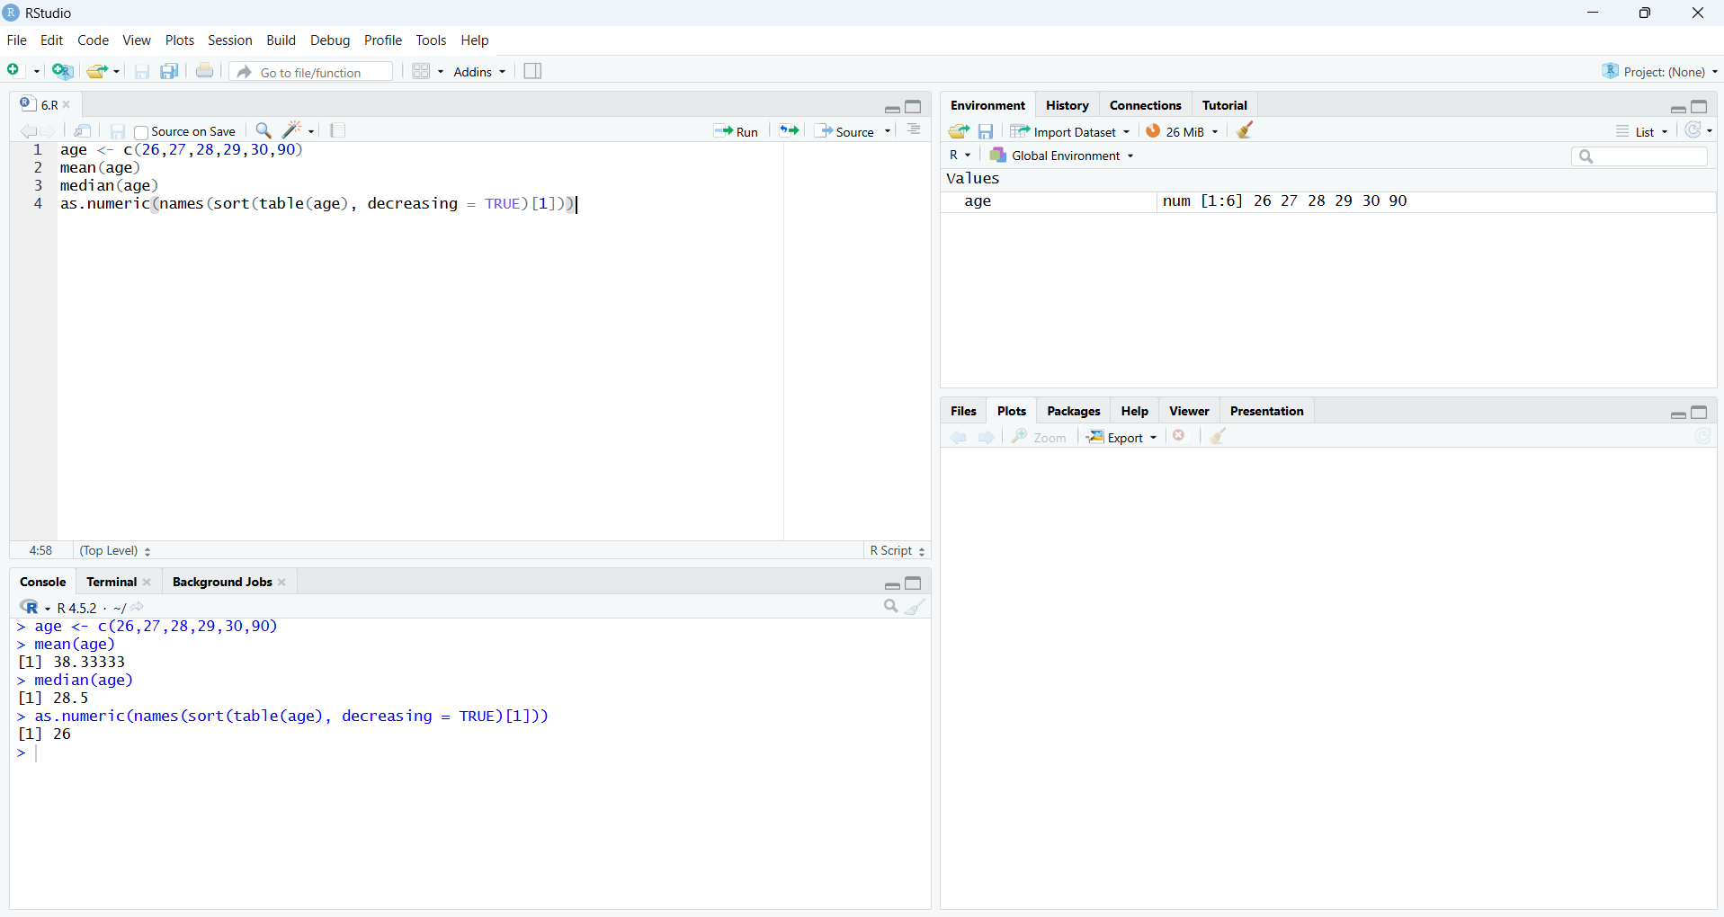

RESULT: Thus the program for mean, median and mode was executed successfully.

EXPERIMENT - 7: SUMMARY

AIM:
To write/prove the R program for summary using RStudio.

PROGRAM:
names <- c("siri","mahi","chiru")
age <- c(23,24,25)
marks <- c(88,78,25)
df <- data.frame(names, age, marks)
summary(df)
write.csv(df, "student_data.csv", row.names = FALSE)
OUTPUT:
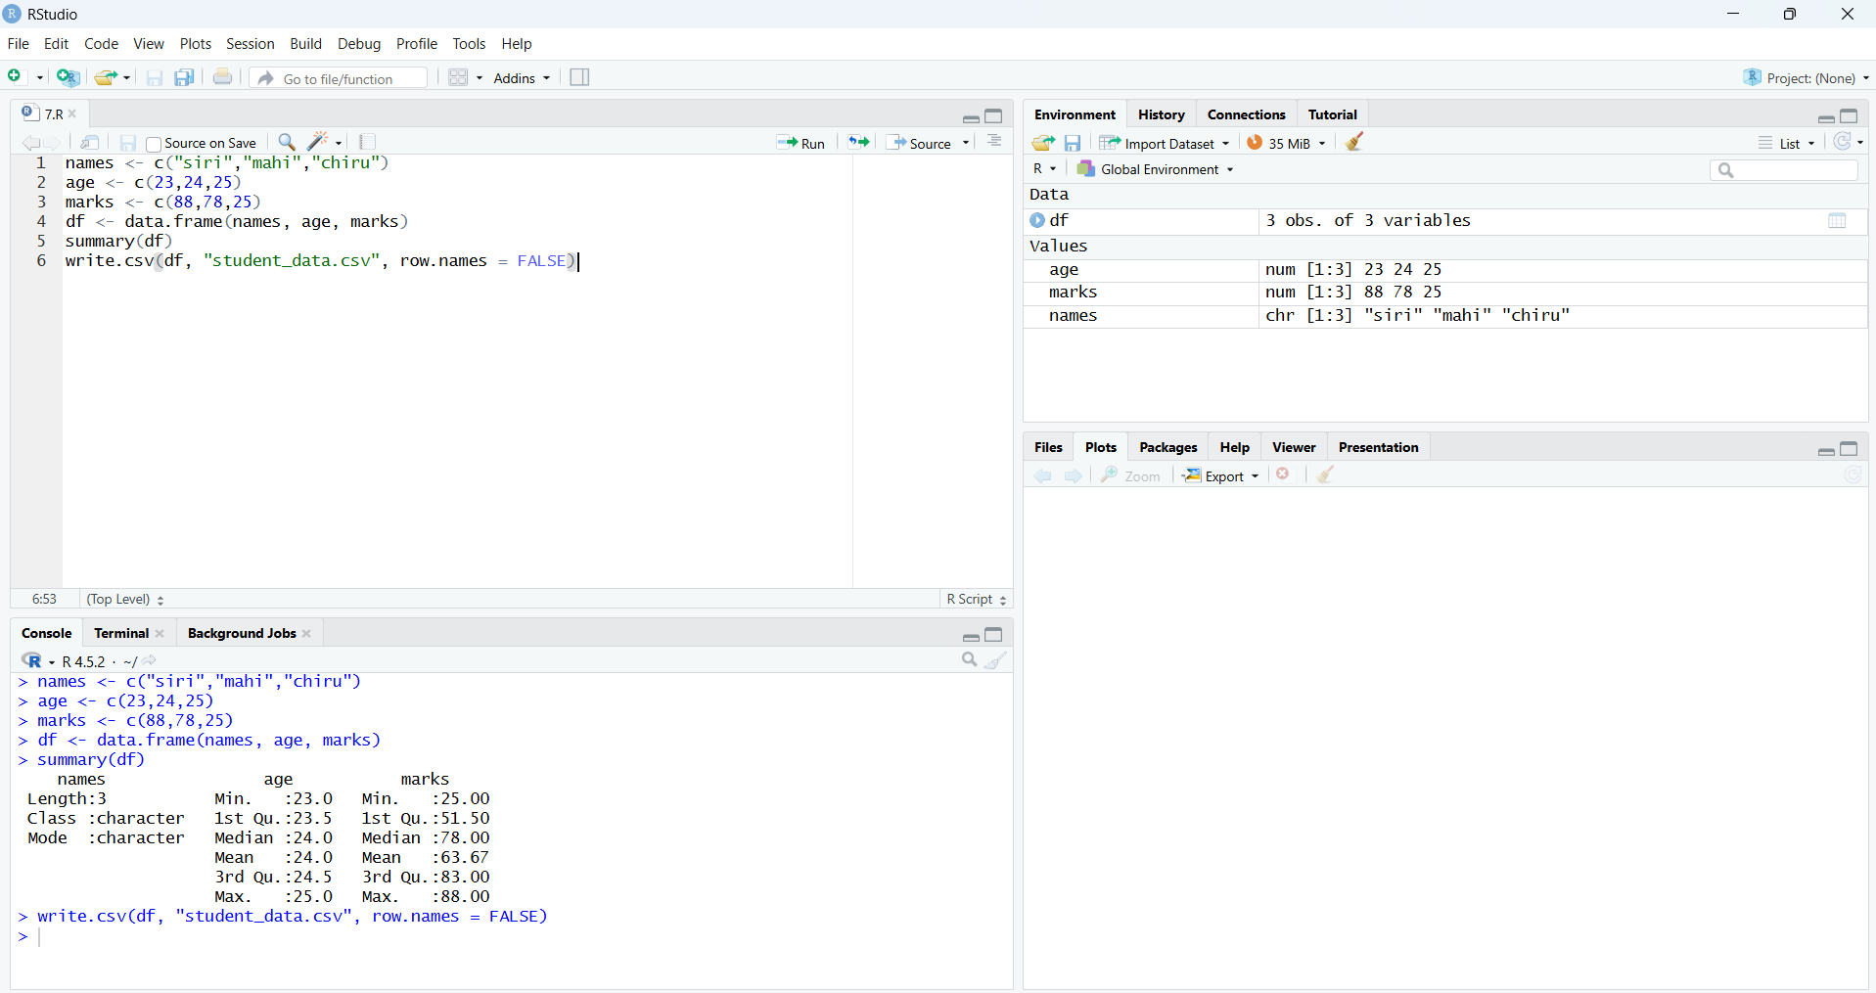

RESULT: Thus the program to compute summary statistics was executed successfully.

EXPERIMENT - 8: GREATEST AMONG THREE NUMBERS

AIM:
To write/prove the R program for greatest among three numbers using RStudio.

PROGRAM:
x <- 5
y <- 8
z <- 7

print(paste("Greatest is:", max(x, y, z)))
OUTPUT:
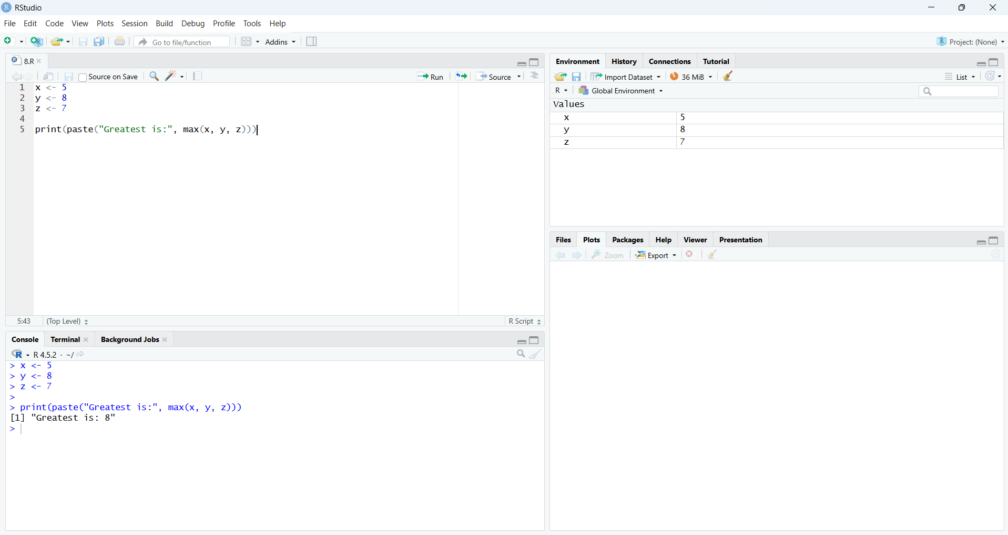

RESULT: Thus the program to find the greatest among three numbers was executed successfully.

EXPERIMENT - 9: INTER-QUARTILE RANGE (IQR)

AIM:
To write/prove the R program for inter-quartile range (iqr) using RStudio.

PROGRAM:
names<-c("siri","mahi","chiru")
age<-c(23,24,25)
marks<-c(88,78,25)
df<-data.frame(names,age,marks)
IQR(df $age)
write.csv(df,"datafr.csv")
OUTPUT:
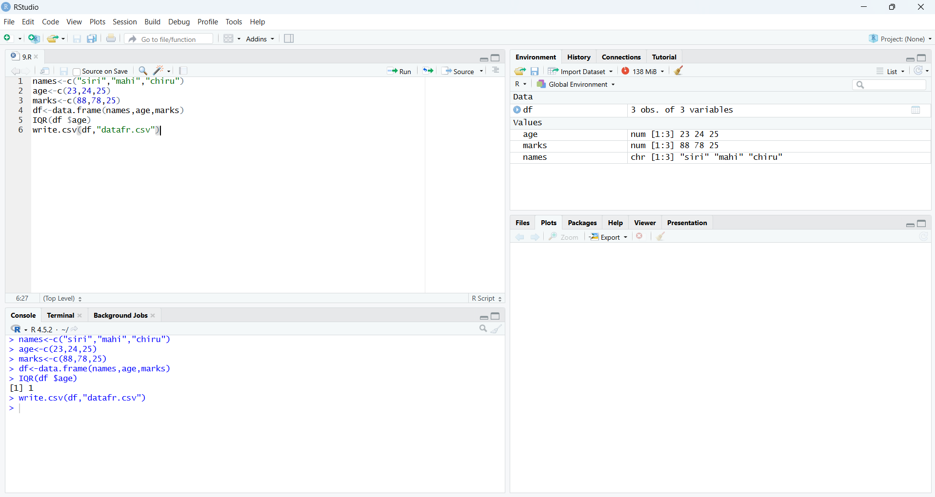

RESULT: Thus the program for central tendency and data dispersion (IQR) was executed successfully.

EXPERIMENT - 10: QUANTILE

AIM:
To write/prove the R program for quantile using RStudio.

PROGRAM:
names<-c("siri","mahi","chiru")
age<-c(23,24,25)
marks<-c(88,78,25)
df<-data.frame(names,age,marks)
IQR(df $age)
write.csv(df,"datafr.csv")
OUTPUT:


RESULT: Thus the program for central tendency and data dispersion (Quantile) was executed successfully.

EXPERIMENT - 11: MID RANGE

AIM:
To write/prove the R program for mid range using RStudio.

PROGRAM:
x <- c(10, 20, 30, 40, 50)
mid_range <- (min(x) + max(x)) / 2
mid_range
OUTPUT:
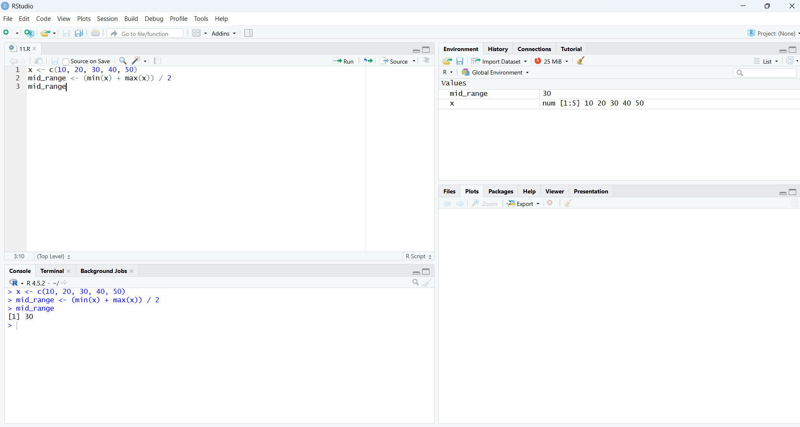

RESULT: Thus the program for central tendency and data dispersion (Mid Range) was executed successfully.

EXPERIMENT - 12: Z-SCORE NORMALIZATION

AIM:
To write/prove the R program for z-score normalization using RStudio.

PROGRAM:
x <- c(10, 20, 30, 40, 50)
z_score <- (x - mean(x)) / sd(x)
z_score
OUTPUT:
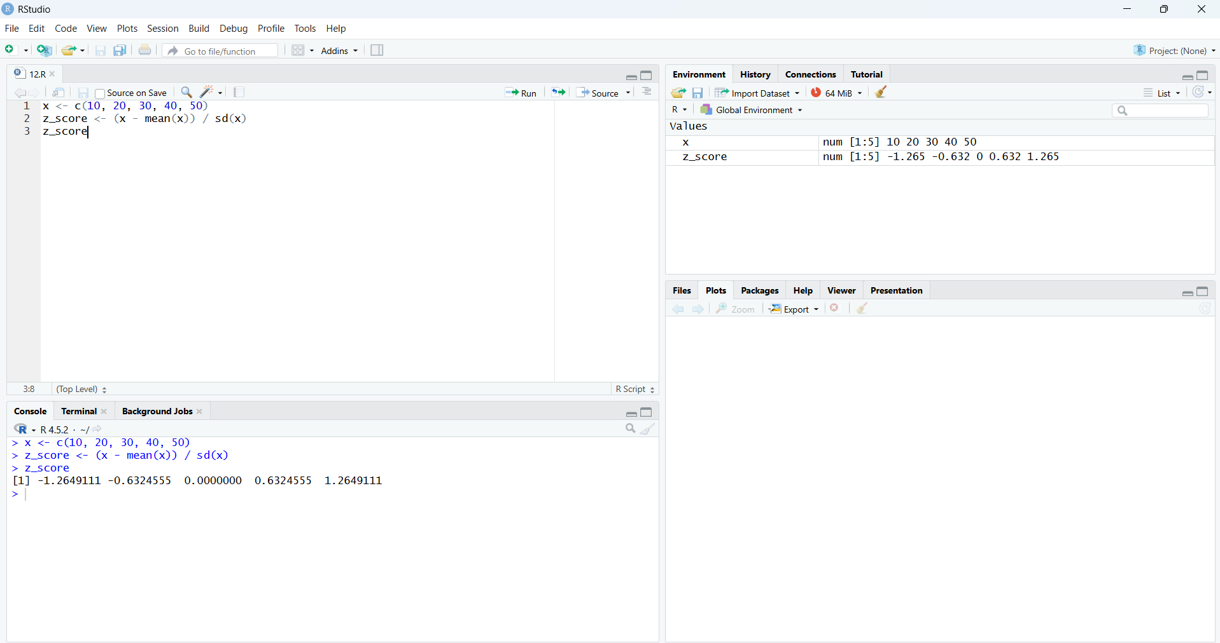

RESULT: Thus the Z-score normalization using R tool was executed successfully.

EXPERIMENT - 13: MIN, MAX, MEAN, MINMAX

AIM:
To write/prove the R program for min, max, mean, minmax using RStudio.
PROGRAM:
x <- c(10, 20, 30, 40, 50)
min_value <- min(x)
max_value <- max(x)
mean_value <- mean(x)
minmax_norm <- (x - min_value) / (max_value - min_value)
min_value
max_value
mean_value
minmax_norm
OUTPUT:

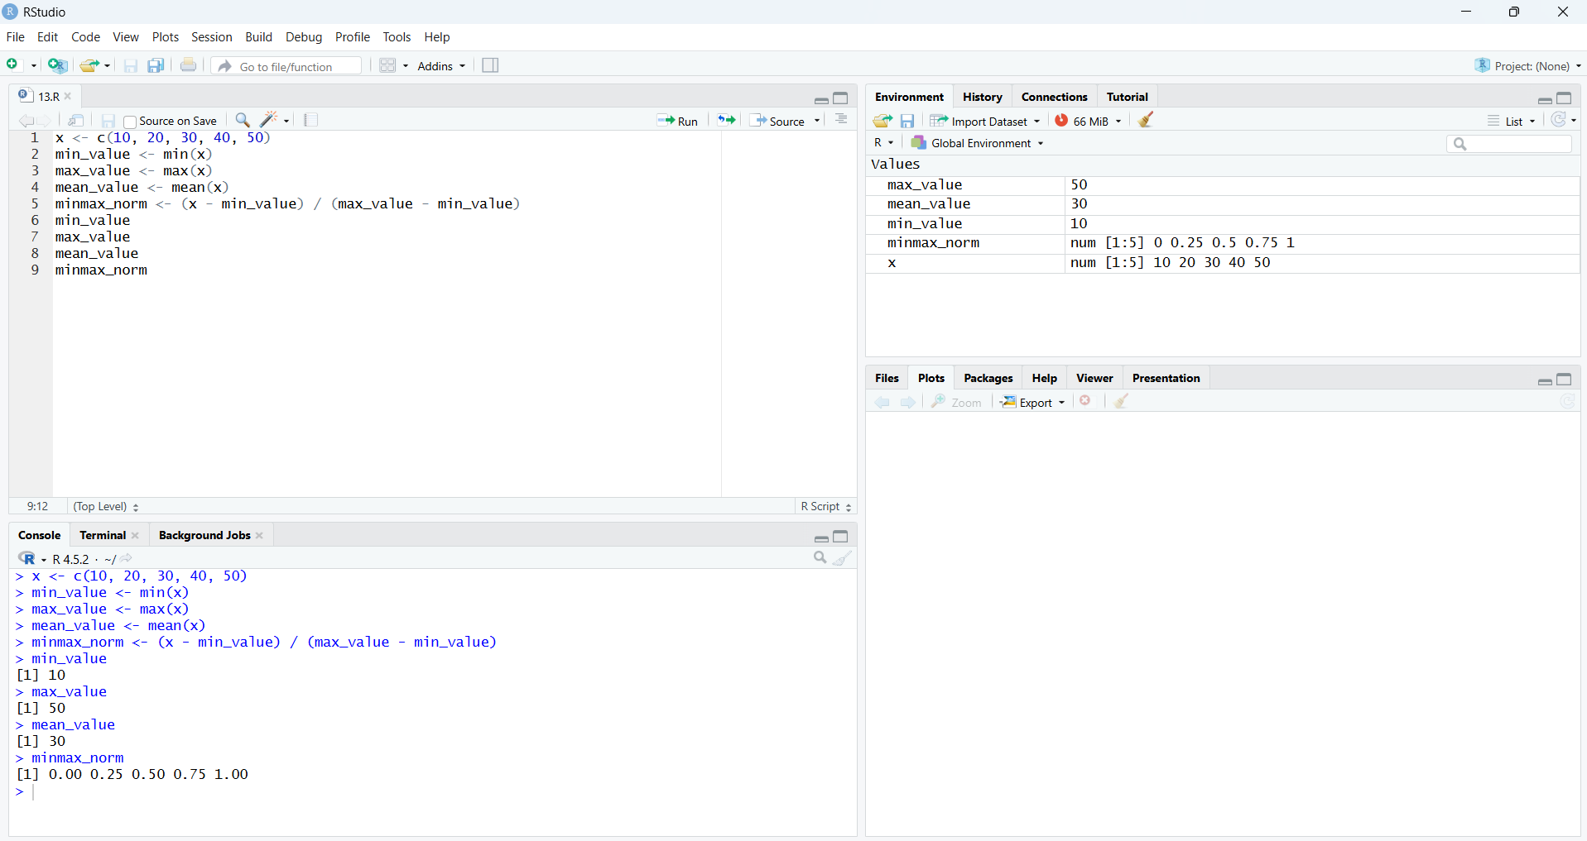

RESULT: Thus the program for min, max, mean and min-max normalization was executed successfully.

EXPERIMENT - 14: BAR PLOT AND HORIZONTAL BAR

AIM:
To write/prove the R program for bar plot and horizontal bar using RStudio.

PROGRAM:
a<-c(55,67,89,80,90)
barplot(a)
a<-c(55,67,89,80,90)
barplot(a)
barplot(a,horiz=TRUE)
OUTPUT:
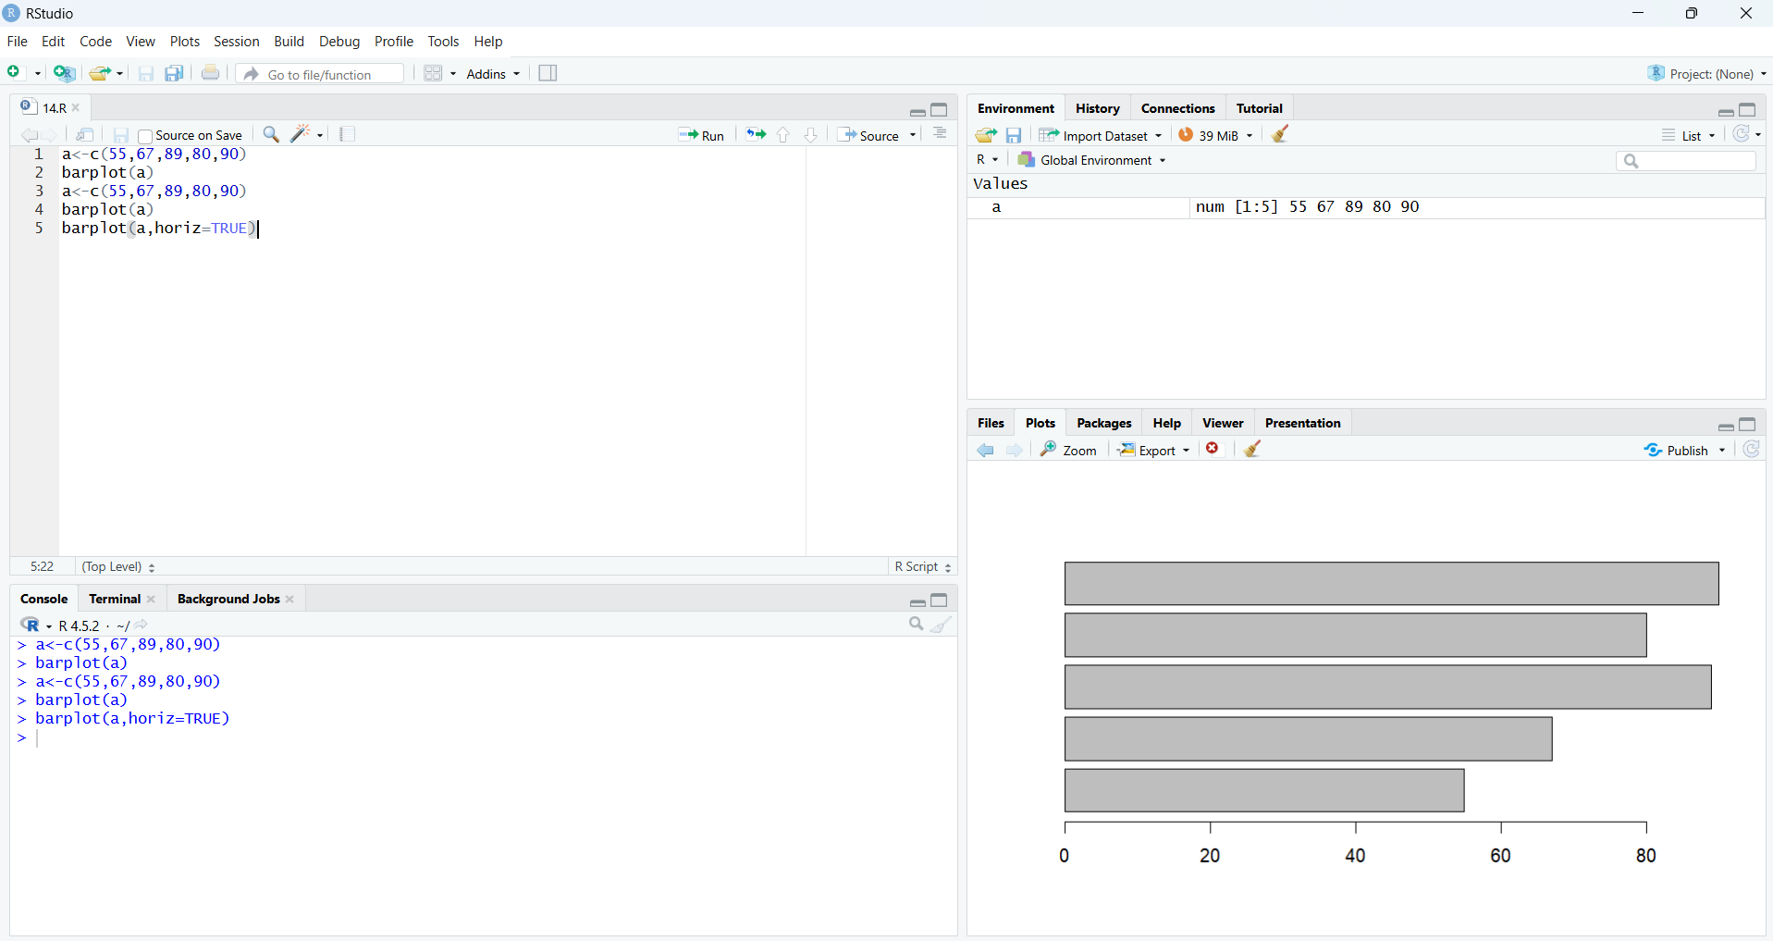

RESULT: Thus the bar plot and horizontal bar plot were drawn successfully.

EXPERIMENT - 15: BOX PLOT

AIM:
To write/prove the R program for box plot using RStudio.

PROGRAM:
name <- c("siri", "chru", "loki")
age <- c(23, 24, 25)
marks <- c(88, 78, 25)
df <- data.frame(name, age, marks)
hist(df$age)
boxplot(df$age)
OUTPUT:
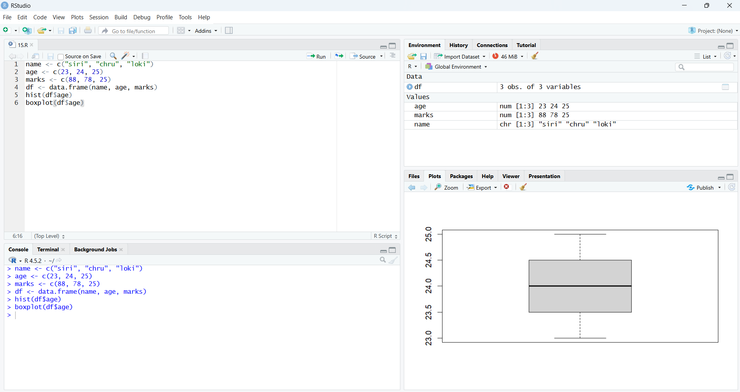

RESULT: Thus the box plot was drawn successfully.

EXPERIMENT - 16: HISTOGRAM

AIM:
To write/prove the R program for histogram using RStudio.

PROGRAM:
a<-c(55, 67, 89, 80, 90 )
hist(a)
OUTPUT:
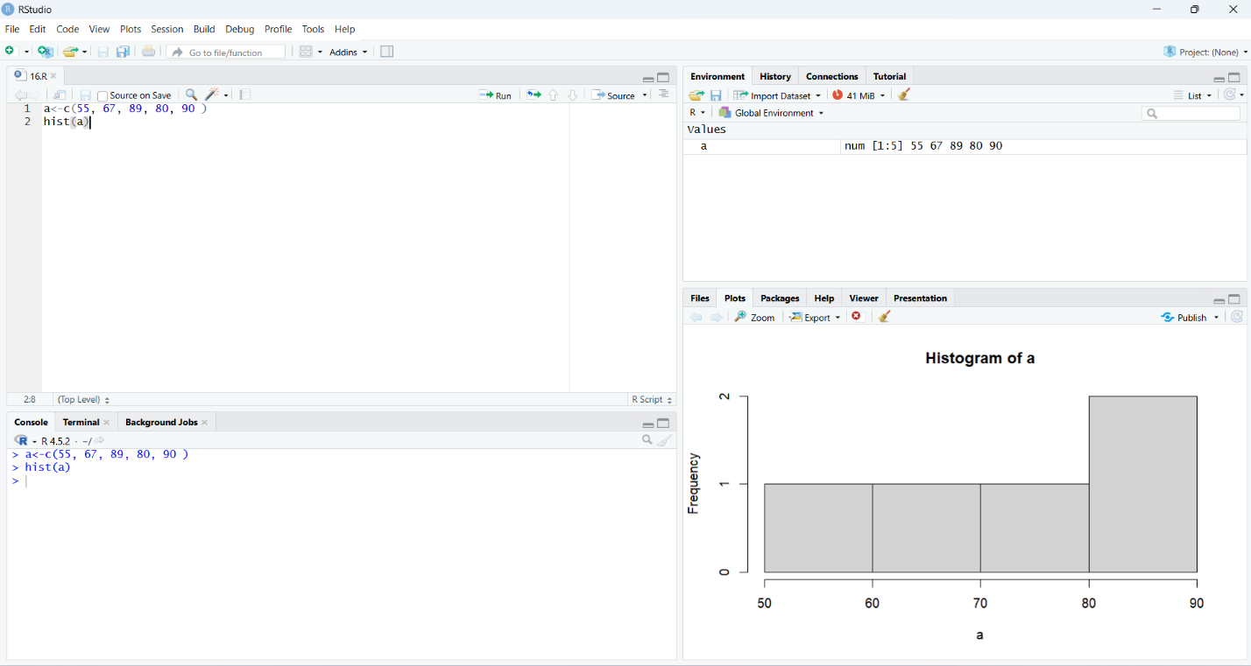

RESULT: Thus the histogram plot was drawn successfully.

EXPERIMENT - 17: CORRELATION ANALYSIS

AIM:
To write/prove the R program for correlation analysis using RStudio.

PROGRAM:
x <- c(10, 20, 30, 40, 50)
y <- c(15, 25, 35, 45, 55)
cor(x, y)
OUTPUT:
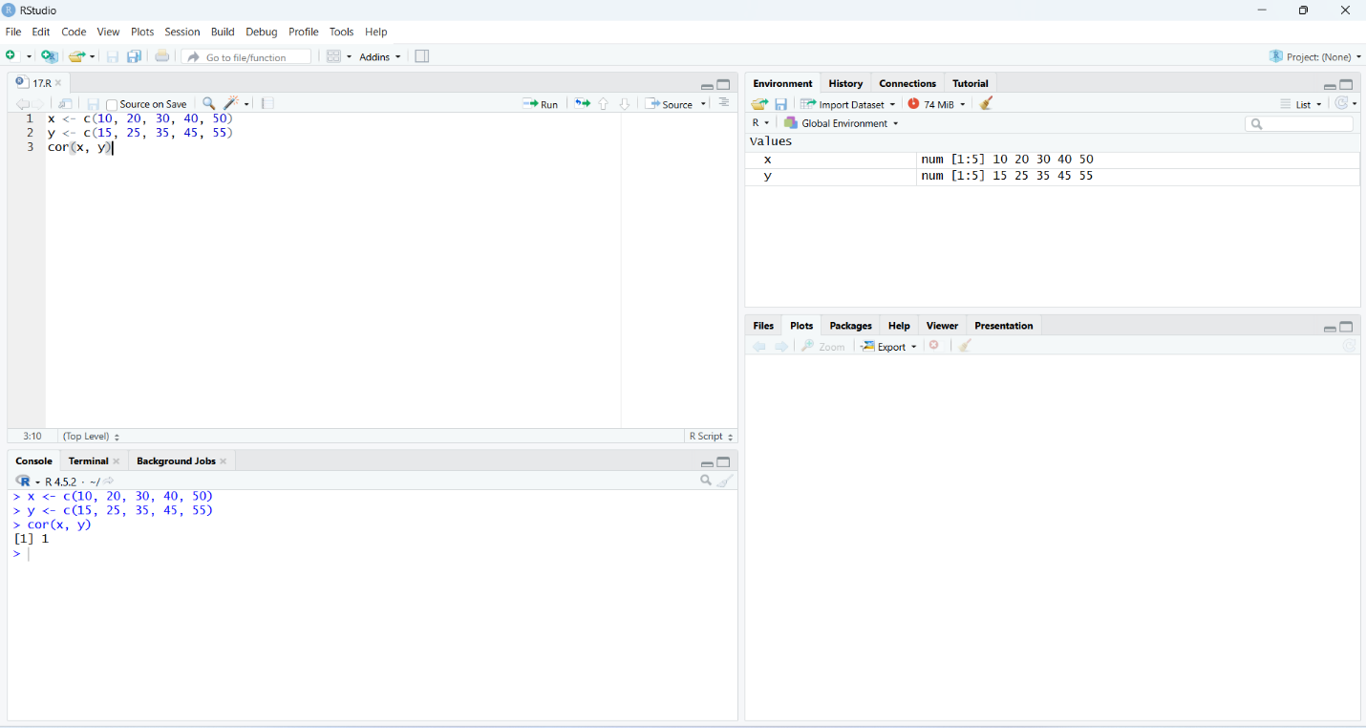

RESULT: Thus the correlation analysis using R tool was executed successfully.

EXPERIMENT - 18: SCATTER PLOT

AIM:
To write/prove the R program for scatter plot using RStudio.

PROGRAM:
x <- c(1, 2, 3, 4, 5, 6, 7, 8, 9, 10)
y <- c(2, 4, 5, 4, 6, 7, 8, 9, 10, 12)

plot(x, y,
main = "Scatter Plot",
xlab = "X values",
ylab = "Y values",
col = "blue",
pch = 19)
OUTPUT:
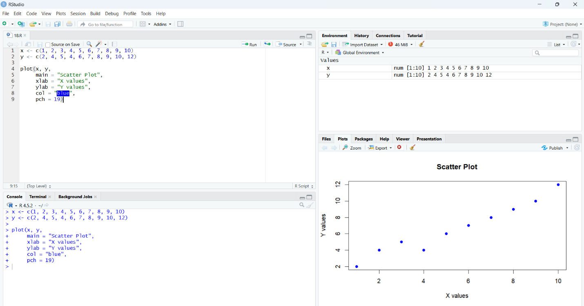

RESULT: Thus the scatter plot was drawn successfully.

EXPERIMENT - 19: LINEAR REGRESSION
AIM:
To write/prove the R program for linear regression using RStudio.
PROGRAM:
x <- c(10, 20, 30, 40, 50)
y <- c(14, 27, 33, 46, 52)
model <- lm(y ~ x)
summary(model)
plot(x, y,
main = "Linear Regression",
xlab = "X values",
ylab = "Y values",
col = "blue",
pch = 19)
abline(model, col = "red", lwd = 2)
OUTPUT: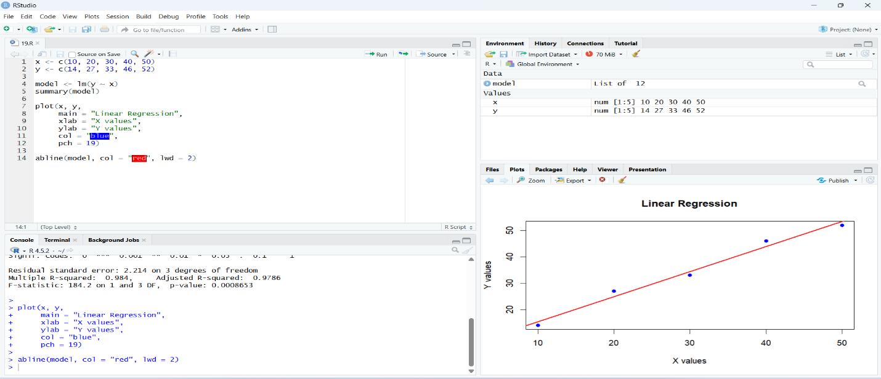

RESULT: Thus the linear regression program was executed successfully.

EXPERIMENT - 20: MULTIPLE REGRESSION

AIM:
To write/prove the R program for multiple regression using RStudio.

PROGRAM:
age <- c(20,25,30,35,40)
weight <- c(55,60,65,70,75)
bp <- c(120,125,130,138,145)
data <- data.frame(age, weight, bp)
model <- lm(bp ~ age + weight, data=data)
print(summary(model))
OUTPUT:
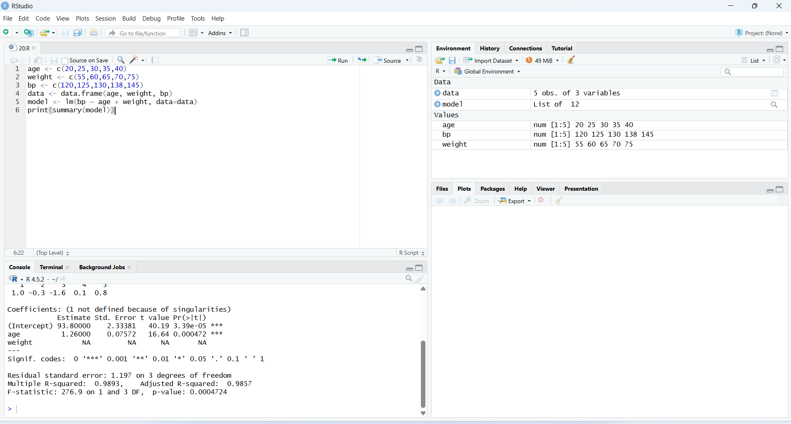
RESULT: Thus the multiple regression program was executed successfully.

